Date & Name of Event | Significance | Image or more information
1788, Convicts arrived | First ships of people brought to the country were convicts, soldiers, and families of the soldiers. First livestock brought | 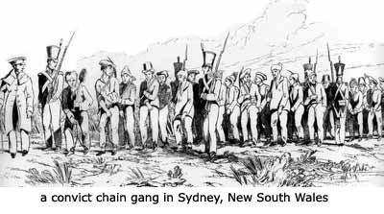  http://warrenfahey.com/revival_ozmusic2.html
January 26, 1788 | Captain Phillip took a party ashore Sydney Cove, raised the British colors and British sovereignty over New South Wales was formally proclaimed. This day is now celebrated as Australia Day. | 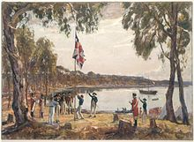  http://en.wikipedia.org/wiki/History_of_Sydney
1840-1843 | Australia's first municipal authority, the City of Adelaide, was established, followed by Sydney City Council. Australia's first parliamentary elections was held for the New South Wales Legislative Council (though voting rights are restricted to males of certain wealth or property). | 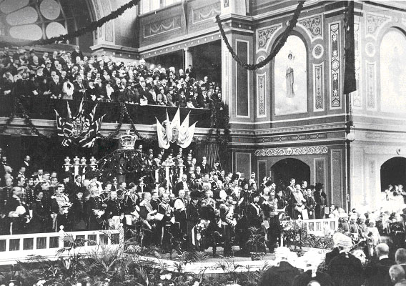  http://www.aph.gov.au/About_Parliament/  Senate/Powers_practice_n_procedures/briefs/brief02
1850 | Australia's first university, the University of Sydney, was founded. | 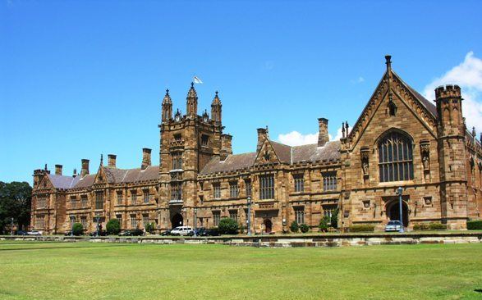  http://sydney.edu.au/
1867 | Gold was discovered at Gympie, Queensland. | 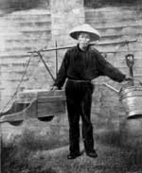  http://australia.gov.au/about-australia/  australian-story/austn-gold-rush
1869 | Children of Australian Aboriginal and Torres Strait Islander descent are removed from their families by Australian and State government agencies. This practice lasted 100 years and is known as the Stolen Generation. | 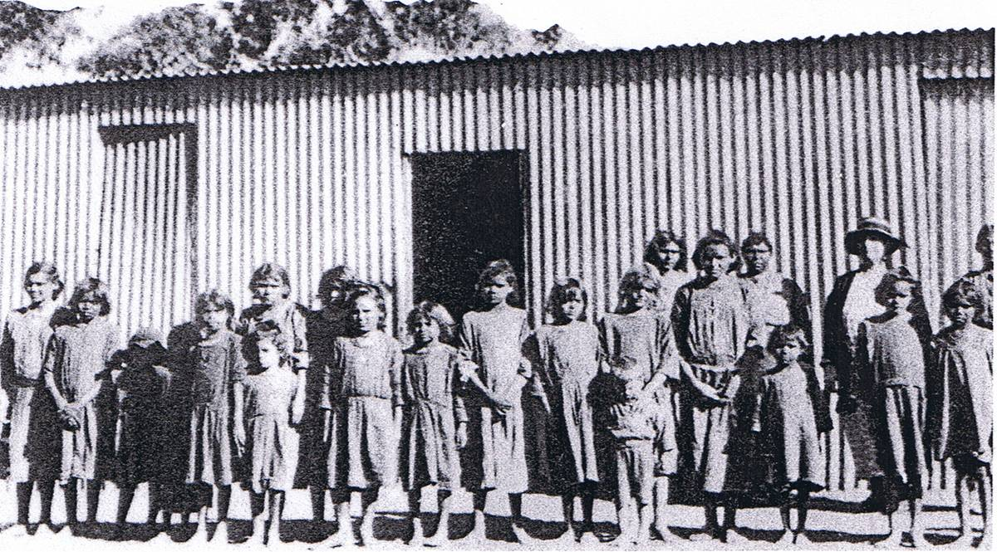  http://www.nsdc.org.au/stolen-generations/  history-of-the-stolen-generations/the-history  -of-the-stolen-generations
1891 | The name "the Commonwealth of Australia," put into play & also the drafting of the constitution. | http://www.nationsonline.org/oneworld/australia.htm
1900 | - The constitution was passed by the Parliament of the UK as a schedule to the Commonwealth of Australia Constitution Act, and was given royal assent | 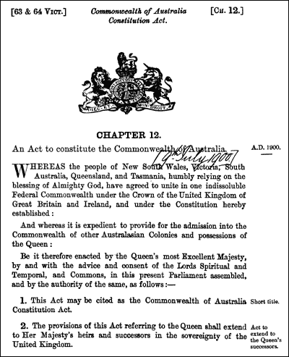 http://www.aph.gov.au/About_Parliament/  Senate/Powers_practice_n_procedures/Constitution
January 1, 1901 | Australia becomes a federation. Edmund Barton becomes the 1st Prime Minister of Australia;  The Australian National Flag was flown for the first time | http://www.nationsonline.org/oneworld/australia.htm
1911 | - The Royal Australian Navy is founded | 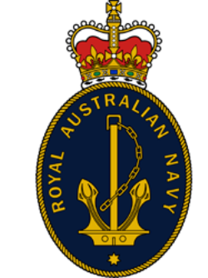  http://www.navy.gov.au/
1914 | - Australian soldiers are sent to the First World War: First time Australians had fought under the their flag, as opposed to that of Britain's. | 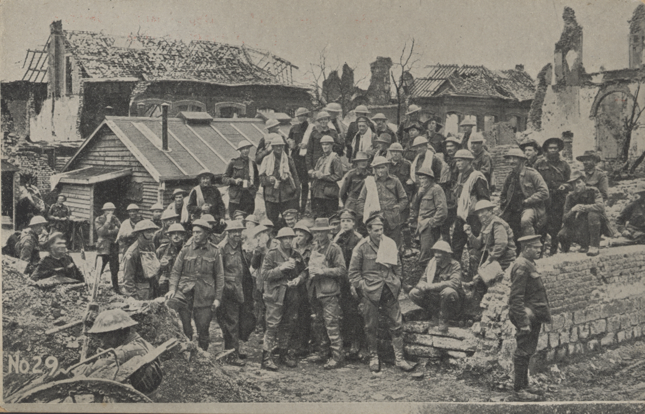  http://www.awm.gov.au/atwar/ww1/
1918 | - First World War ends – 60,000 Australians dead. | 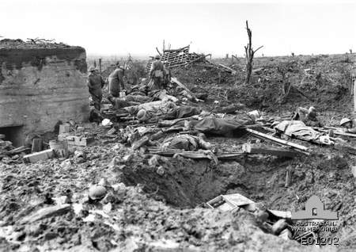  http://www.awm.gov.au/atwar/ww1/
1939 | September, Australia enters the Second World War following the German Invasion of Poland. The 2nd Australian Imperial Force is raised | 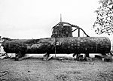  http://www.ww2australia.gov.au/
February 1942 | Fall of Singapore. 15,000 Australians become Prisoners of War of the Japanese | 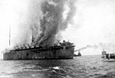  http://www.ww2australia.gov.au/japadvance/  singapore.html

